COMPARATIVE DATA ANALYSIS OF REVENUE RECEIPT FROM FISCAL YEAR 2009-2019

Over the span of 2009-2019, India's fiscal data provides a window into the country's financial health, showing how money flows in and out of the government's coffers. What's striking is the steady rise in tax revenues, especially from sources like income, corporation taxes, and taxes on goods and services. This growth is a testament to India's expanding economy and the government's efforts to reform its tax systems. However, not all revenue streams saw consistent growth. Taxes on property and capital transactions saw \fluctuations, likely influenced by changes in market conditions and government policies. Similarly, interest receipts and dividends varied, reflecting the ups and downs of financial markets and the performance of state-owned enterprises.

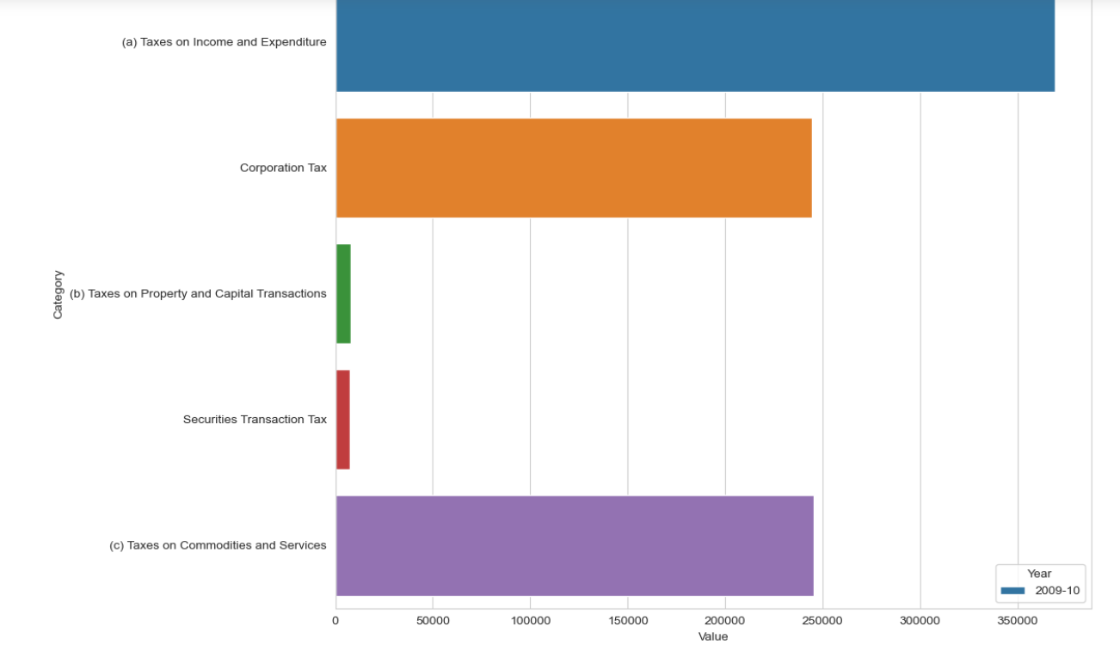

Taxes on property and capital transactions saw some fluctuations, likely influenced by the changes being occurred in the market conditions and the policy of the government. In the similar way, the interest rates and dividends varied, showing ups and downs of the financial markets and the performance of state-owned firms. These allocations aren't just numbers on paper; they represent the government's strategic responses to both local and global issues. They underscore priorities such as national security, economic progress, and efficient governance, reflecting a balance between immediate needs and long-term aspirations. This data isn't just about figures; it's about where the nation invests its resources to shape its future.

